**Bearing**

A **Bearing** is a machine element that constrains relative motion to only the desired motion, and reduces friction between moving parts. The design of the bearing may, provide for free linear movement of the moving part or for free rotation around a fixed axis or, it may prevent a motion by controlling the vectors of normal forces that bear on the moving parts. Most bearings facilitate the desired motion by minimizing friction. Bearings are classified broadly according to the type of operation, the motions allowed, or to the directions of the loads (forces) applied to the parts.

Thus two types of Bearings are

1. **Ball Bearing**
2. **Roller Bearing**
3. **Ball Bearing**

**Ball bearing**, one of the members of the class of rolling, or so-called antifriction, bearings. The function of a ball bearing is to connect two machine members that move relative to one another in such a manner that the frictional resistance to motion is minimal. In many applications one of the members is a rotating shaft and the other a fixed housing.

 It achieves radial and axial load by using at least two races to contain the balls and transmit the loads through the balls. In most applications, one race is stationary and the other is attached to the rotating assembly. As one of the bearing races rotates it causes the balls to rotate as well. Because the balls are rolling they have a much lower coefficient of friction than if two flat surfaces were sliding against each other.

**1.1 Deep Groove Ball Bearing**

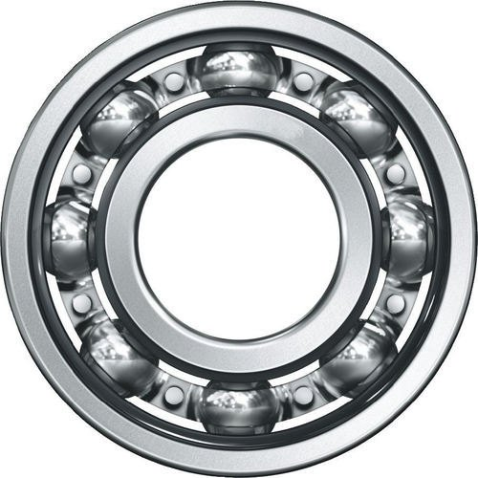

**Deep Groove Ball Bearings** are the most commonly used bearing in almost all sectors, hence most versatile and require basic operating circumstances. They are easy to embed with very low maintenance compared to the others. Their low torque makes them compatible with high speed.

These types of bearings assist both radial and axial forces in both directions. These bearings have less friction and are reformed for reduced vibration and low noise with high rotational speed.

They come in 2 types

1. **Single Row Deep Grove Ball Bearing**
2. **Double Row Deep Grove Ball Bearing**

**1.1.1 Single Row Deep Groove Ball Bearing**

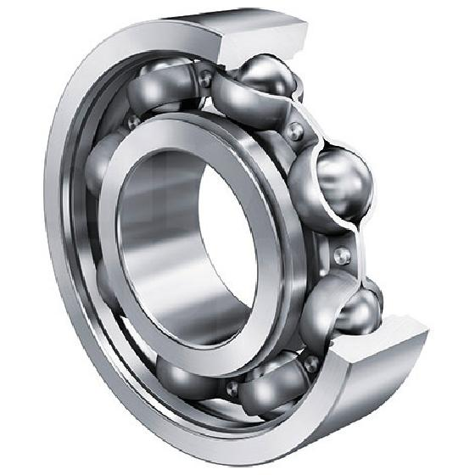

Features

* Low torque with Great rotational speed
* Cost Effective
* Cheap maintenance
* Carry Radial and limited axial load

Single Row Deep Groove Ball Bearings are characterized by having deep raceway grooves in which the inner and outer rings have circular arcs of slightly larger radius than that of the single line of balls placed within the cage. They also have non-separable rings. They can carry radial capacity with ease and can work with limited axial load making it the most versatile and cost economic while also providing with great rotational speed.

They are available in rubber seals or steel shields with one or both sides of the bearing or even open at both sides of the ring. Easy to configure or assemble the bearing without any difficulty. They require well-aligned bearing mountings as there is a high degree of conformity between balls and raceways, the self-aligning capability of deep groove ball bearings is less.

Single row deep groove ball bearings are versatile and are used in space applications, the balance between space and load applications and few heavy load applications.

**1.1.2 Double Row Deep groove Ball Bearing**

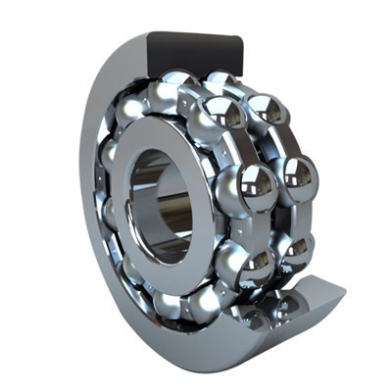

Features

* Pair of single-row deep groove ball bearing for higher load
* Low Noise
* High temperature resistant
* Carry radial and axial load in both direction

Double row deep groove ball bearing assembles with twin single row that has deep interrupted raceway and high conformity between ball and raceways. They are resistant to high temperatures.

# The slightly wider and carry heavier load when compared to single row deep groove bearing and are more efficient as they carry axial loads acting in both directions in addition to radial loads.

**1.2 Angular Contact Ball Bearing**

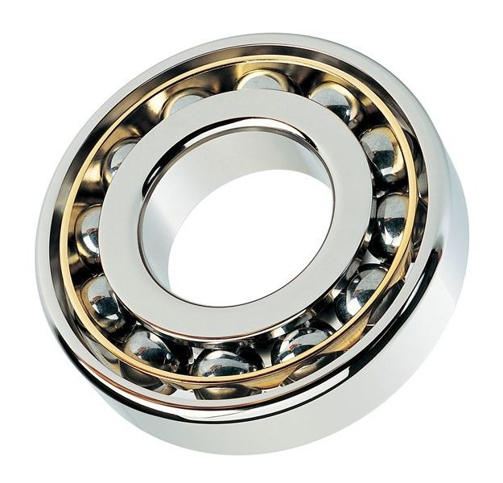

In **Angular Contact Ball Bearings**, the line of action of the load, at the contacts between balls and raceways, forms an angle with the bearings axis. The inner and outer rings are offset to each other and the bearings are particularly suitable for carrying combined radial and axial load. The axial load carrying capacity of angular contact ball bearings increases as the contact angle increases. The contact angle is defined as the angle between the line joining the points of contact of the ball and the raceways in the radial plane, along which the combined load is transmitted from one raceway to another, and a line perpendicular to the bearing axis.

Angular contact ball bearings have inner and outer ring raceways that are displaced relative to each other in the direction of the bearing axis. This means that these bearings are designed to accommodate combined loads hence simultaneously acting radial and axial loads.

Types of Angular Contact Ball Bearing are

1. **Single Row Angular Contact Ball Bearing**
2. **Double Row Angular Contact Ball Bearing**

**1.2.1 Single Row Angular Contact Ball Bearing**

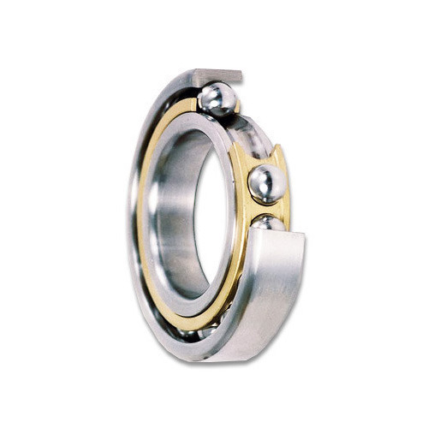

Features

* High Dynamic load carrying capacity
* Reduced friction
* Quiet Run
* High speed with low heat generation within bearing
* High Operating life

**Single Row Angular Contact Ball Bearings** have single raceway grooves in the inner and outer rings that are relatively offset. These bearings can support axial loads in one direction only and are to adjust against another bearing if the axial load is coming from both the directions. Each bearing can be located endwise in one direction only.

Single-row Angular Contact ball bearings can sustain the radial, axial or composite load, however, the axial load must be in one direction.

* + 1. **Double Row Angular Contact Ball Bearing**

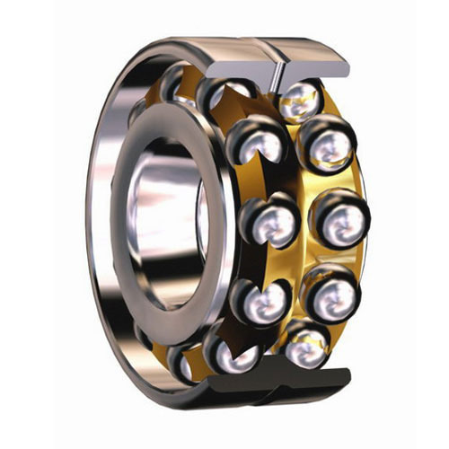

Features

* Lower Noise Levels
* Reduced Friction
* Improved Seals
* Less Lubrication consumption
* Higher Cost Effective

**Double Row Angular Contact Ball Bearings** are units with solid inner and outer rings and ball and cage assemblies with polyamide or sheet steel cages. Their construction is similar to a pair of single row angular contact ball bearings in an O arrangement but they are narrower to a certain extent.

This means that they are designed to accommodate and simultaneously action axial and radial loads. Due to angular contact, the axial load carrying capacity of angular contact ball bearings increases as the contact angle increases. The contact angle is defined as the angle between the line joining the points of contact of the ball and the raceways in the radial plane along which the load is transmitted from one raceway to another, and a line perpendicular to the bearing axis. These bearings can accommodate thrust in both directions. The chief advantages of the double row type are rigidity, compactness and high capacity.

**1.3 Self Aligning Ball Bearing**

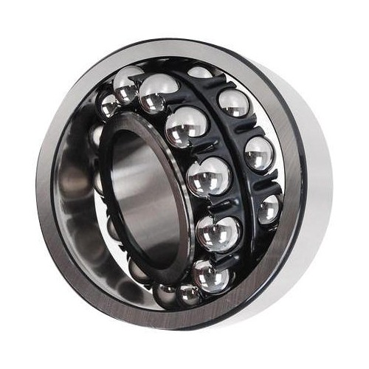

**Self-Aligning Ball Bearings** have a double row of balls guided by a common sphered raceway in the outer ring and two deep uninterrupted raceway grooves in the inner ring and have the special feature of a continuous spherical outer ring raceway allowing the inner ring/ball complement to swivel within the outer ring. This is what enables a degree of self-alignment in the application.

The bearings are insensitive to the angular misalignment of the shaft relative to the housing, therefore, this type of bearing is recommended when the alignment of the shaft and the housing (misalignment) are a problem and the shaft could deflect. Self-aligning ball bearings are most suitable for absorbing radial forces.

A self-aligning bearing is recommended when the alignment of the shaft and housing is difficult or when the shaft may bend during operation, the bearing would be selected based on the load, speed and space constraints of the application. Also, the misalignment and/or shaft bending amount should be considered when specifying a bearing type.

**2. Roller Bearing**

**Roller Bearings** are a type of rolling-element bearing that uses cylinders (rollers) to maintain the separation between the moving parts of the bearing (as opposed to using balls as the rolling element). The purpose of a roller bearing is to reduce rotational friction and support radial and axial loads. Compared to ball bearings, roller bearings can support heavy radial loads and limited axial loads (parallel to the shaft). They can operate at moderate to high speeds (although maximum speeds are typically below the highest speeds of ball bearings). The lubrication method must carefully be considered during the design phase when using roller bearings.

**2.1 Cylindrical Roller Bearing**

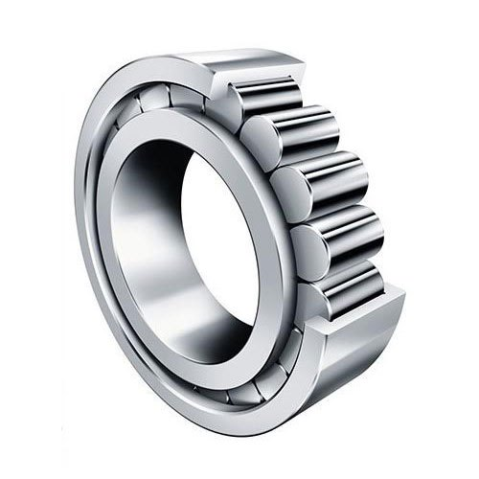

**Cylindrical Roller Bearing** is available in various designs, series, size and variants. The basic difference is the number of rollers and the flanges either inner or outer.

In bearings of this type, the cylindrical rollers are in linear contact with the raceways. They have a high radial load capacity and are suitable for high speed. Accommodating axial displacement (except for bearings with flanges on both the inner and outer rings), they offer high stiffness, low friction and long service life.

Some cylindrical roller bearings have no ribs on either the inner or outer ring, so the rings can move axially relative to each other. These can be used as free-end bearings. Cylindrical roller bearings, in which either the inner or outer rings has two ribs and the other ring has one, are capable of taking some axial load in one direction Double-row cylindrical roller bearings have high radial rigidity and are used primarily for precision machine tools.

* + 1. **Single Row Cylindrical Roller Bearing**

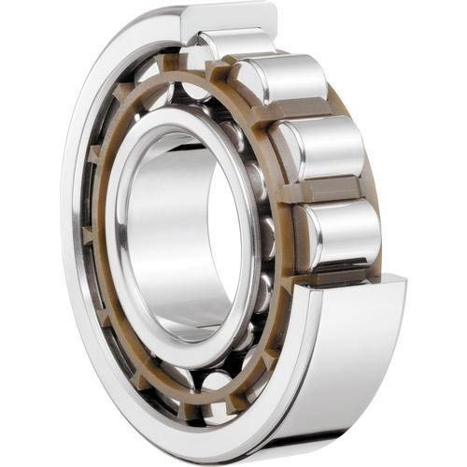

Features

* High speed capability
* Low friction
* Long service free life
* Separable and interchangeable

**Single Row Cylindrical Roller Bearing** is designed to support heavy radial loads. These roller bearings consist of an Outer Race, Bronze or Steel Cage, a complement of rollers, and usually an Inner Race.

The rollers are guided by the ribs of the inner or outer ring. The inner and outer rings can be separated to facilitate assembly, and both can be fit with shaft or housing tightly. If there are no ribs, either the inner or the outer ring can move freely in the axial direction.

In the case where there is a rib, the bearing can bear a slight axial load between the end of the rollers and the rib.

Types NU, N, NNU, and NN are suitable as free-end bearings. Types of NJ and NF can sustain limited axial loads in one direction. Types NH and NUP can be used as fixed-end bearings.

NH-type cylindrical roller bearings consist of the NJ-type cylindrical roller bearings and HJ-type L-shaped thrust collars.

The inner ring loose rib of a NUP-type cylindrical roller bearing should be mounted so that the marked side is on the outside.

**2.1.2 Double Row Cylindrical Roller Bearing**

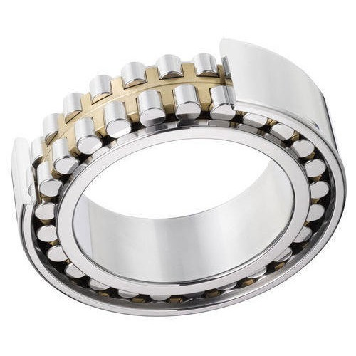

Features

* High load carrying capacity
* Low friction
* Separable and interchangeability
* Low friction
* Enhanced operation reliability

**Double Row Cylindrical Roller Bearings** are designed for heavy loads that can’t be serviced with a single-row bearing. The additional row of rollers allows for the increased radial loads. Double row cylindrical bearings are typically metric dimensioned with a machined brass cage. The cage is a one-piece roller riding brass finger cage that promotes smooth rolling.

These bearing types are interchangeable so the dimensions and diameter under the rollers (NNU style) and diameter over the rollers (NN style) are held to a standard. Interchangeability is designed for the ring without the rollers to allow interchange with competitor inner rings.

Double row cylindrical roller bearings are available in several designs with a cylindrical or tapered bore. Current designs use NN, NNU, NNUP nomenclature.

* 1. **Needle Roller Bearing**

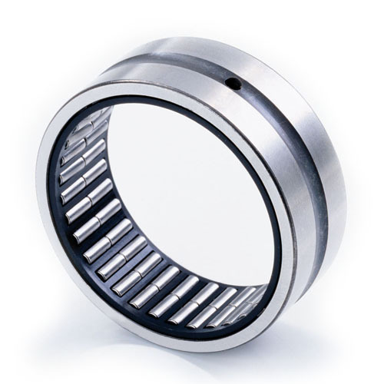

**Needle Roller Bearing** is a special type of roller bearing which uses long, thin cylindrical roller resembling needles. Ordinary roller bearings' rollers are only slightly longer than their diameter, but needle bearings typically have rollers that are at least four times longer than their diameter bearings with cylindrical rollers that are small in diameter relative to their length. The modified roller/raceway profile prevents stress peaks to extend bearing service life.

Compared to ball bearings and ordinary roller bearings, needle bearings have a greater surface area in contact with the races, so they can support a greater load. They are also thinner, so they require less clearance between the axle and the surrounding structure.

A lot of classification and characteristics when it comes to needle roller.

Thrust Needle Roller Bearing

This bearing comprises needle rollers or cylindrical rollers, a cage to guide and retain properly the rollers, and disc-shaped rolling bearing ring. This is a bearing capable of supporting one-way axial load. Furthermore, this bearing can be used without a rolling bearing ring, where the heat-treated and ground bearing mount surface can be used as the raceway surface.

* 1. **Tapered Roller Bearing**

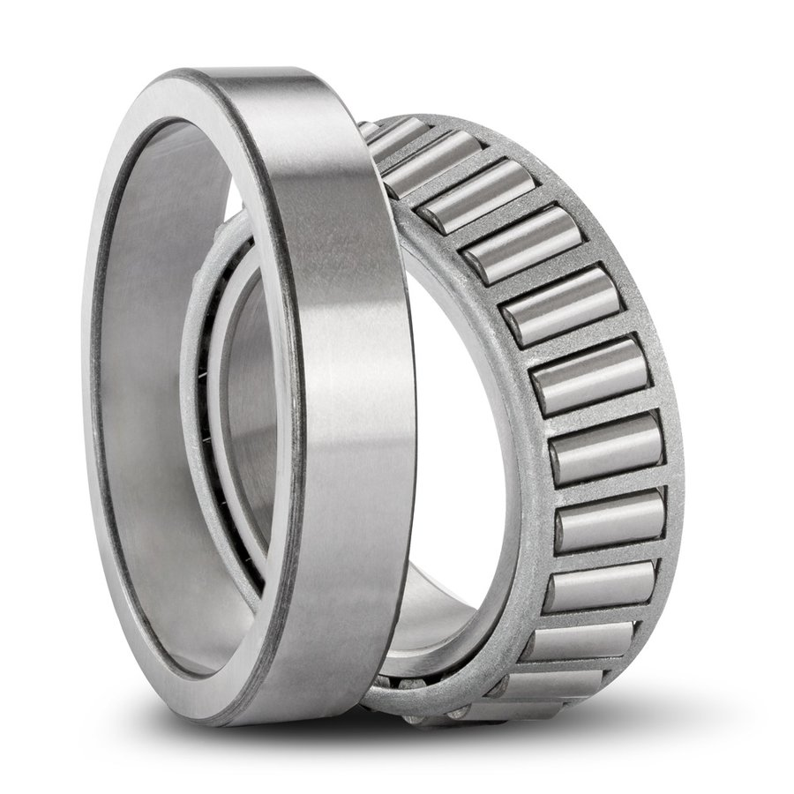

The **Taper Roller Bearing** is a separable type bearing which inner components (consists of rollers, cage, and inner ring) can be separated from the outer ring. Therefore, it can be very easily installed onto the journal and bearing housing.

These bearings are commonly used for moderate speed, heavy-duty applications where durability is required such as machine tool spindles, rolling mills, mining equipment, metallurgy industry, plastics making machinery and other industries.

They are also customizable to match your specific speed, load, contamination, temperature or vibration conditions.

Tapered roller bearings feature a cup and cone assembly. The cup is comprised of the outer ring and the cone assembly consists of an inner ring, rollers, and cage. This bearing construction accommodates combined loads and provides low friction during operation. By adjusting one single row tapered roller bearing against a second tapered roller bearing and applying a preload, a rigid bearing application can be achieved.

* + 1. **Single Row Tapered Roller Bearing**

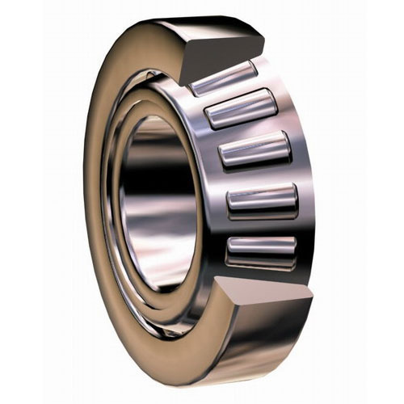

Features

* Rigid Bearing application
* **Separable and interchangeable**
* Enhanced operational reliability
* **Low friction**
* **Long service life**

**Single Row Tapered Roller Bearing** is the basic and the most widely used type of tapered roller bearing. It consists of the inner-ring assembly and the outer ring. It is usually fitted as one of an opposing pair. During equipment assembly, single-row bearings can be “set” to the required clearance (endplay) or preload condition to optimize performance.

These are designed to accommodate combined loads, i.e. simultaneously acting radial and axial loads. The projection lines of the raceways meet at a common point on the bearing axis to provide a true rolling action and therefore low frictional moments during operation.

* + 1. **Double Row Tapered Roller Bearing**

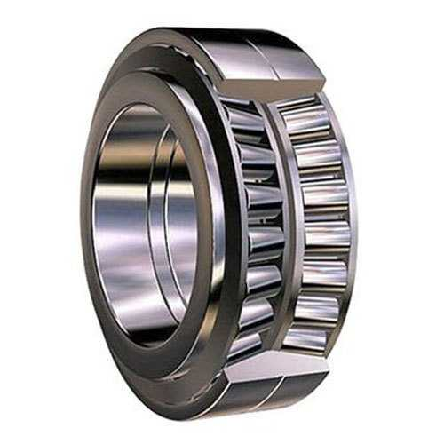

Features

* **High load carrying capacity**
* **High stiffness**
* **Axial loads in both directions**
* **Low friction**
* **Long service life**

**Double Row Tapered Roller Bearing** has a one-piece (double) outer ring and two single inner rings. It is usually supplied complete with an inner-ring spacer as a pre-set assembly. This configuration gives a wide effective bearing spread and is frequently chosen for applications where overturning moments are a significant load component. These bearings can be used in fixed (locating) positions or allowed to float in the housing bore. These outer rings have holes in the outer diameter that permit the use of pins to prevent outer ring rotation in the housing.

Depending on the design, these bearings can accommodate heavy radial loads, axial loads in both directions and have a high degree of stiffness. Double row tapered roller bearings are typically used in gearboxes, hoisting equipment, rolling mills and machines in the mining industry.

* + 1. **Four Row Tapered Roller Bearing**

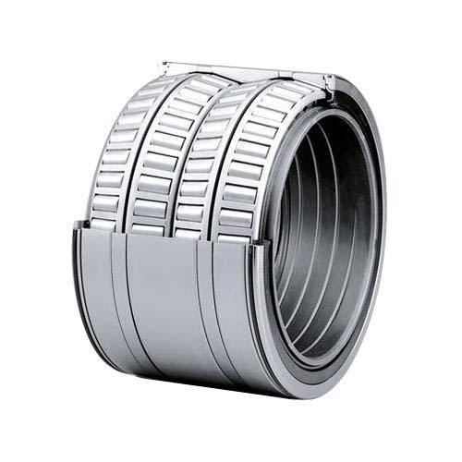

Features

* **Improved wear resistance**
* **Improved sealing performance with less leakage and less frictional heat**
* **Long service life**
* **Enhanced operational reliability**

**Four Row Taper Roller Bearings** are made up of two double row inner rings and two double row outer rings. These bearings are used for heavy load capacity as in the roller necks of rolling mills. The life of large bearings is extended by using case hardened steel, hollow rollers and pin-type cages. The life of large bearings is extended by using case hardened steel, hollow rollers and pin-type cages. These bearings can accommodate both radial and axial load at moderate speed.

* 1. **Spherical Roller Bearing**

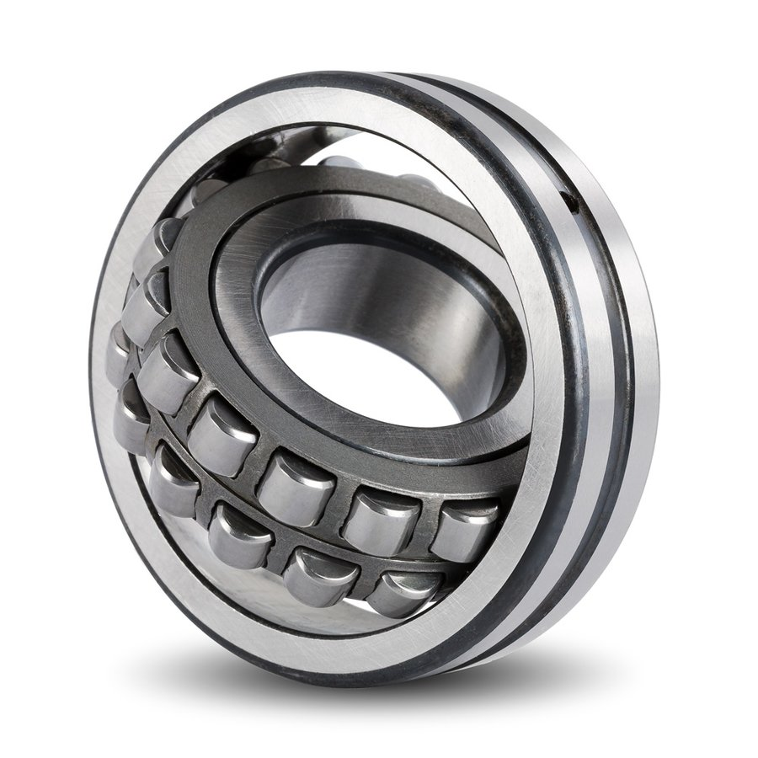

**Features**

* Accommodate misalignment
* High load carrying capacity
* Long service life
* Low friction
* Robust

**Spherical Roller Bearings** are self-aligning bearings designed for heavy radial loading. They automatically compensate for large angular errors (shaft misalignments). They are usually of the double row design, both the rows of the rollers having common spherical raceways in the outer ring.

This feature of this bearing has great practical importance in those cases where it is difficult to obtain exact parallelism between the shaft and housing both axes. So these bearings are suitable where misalignment can arise from mounting errors or from deflection of the shaft. They can take static as well as dynamic misalignment. Spherical roller bearings are particularly suitable for carrying heavy loads. They are commonly found in Industrial Gear boxes, Conveyors, Cement Grinding Rolls, Sugarcane crushers and passenger coach axle boxes of Railways.